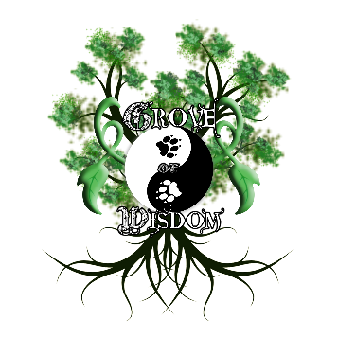
Privacy and Liability Form

NOTICE: All consultee (client) information provided is confidential unless requested by authorities in possession of a warrant. Consultee rights and privacy are protected by law. This form is to be printed and sent to the provided mailing address.

MEDICAL DISCLAIMER: All information provided is intended for general knowledge only and is not a substitute for medical advice or treatment for specific medical conditions. It is highly recommended that readers seek prompt medical care for any specific health issues and consult a physician before starting a new fitness or nutrition regimen. The information given is intended to provide a broader understanding and knowledge of nutritional sciences and all supporting evidence is public domain. The information should not be considered complete and should not be used in place of a visit, call, consultation or advice of your physician or other health care provider. It is not recommended to practice the self-management of health problems without experienced guidance with certification. Information obtained by using the affiliated Site is not exhaustive and does not cover all diseases, ailments, physical conditions or their treatment. You should never disregard medical advice or delay in seeking it because of something you have read there. Should an emergency arise for any reason, please seek immediate medical attention. You should also ask your physician or other healthcare provider to assist you in interpreting any information on the Site or in the linked websites, or in applying the information to your individual case.

OPTIONAL BUT HELPFUL
If possible, please provide current pictures of physical status from the front, side, and back. Pictures are confidential and will not be shared, distributed, or otherwise used in a nefarious manner contrary to professional standards. They are only used as a basis for physical assessment of health which does not include the outdated and inaccurate BMI method.

I have read the above statements and waive liability of any associates affiliated with Grove of Wisdom, and of the Grove of Wisdom team itself. I understand any and all information is not to be interpreted as medical advice, but as educational. I understand that I have the responsibility to keep track of my own health, and that I have the right to refuse information. I understand that should the need arise, I shall seek immediate medical attention. Signature can be in the form of a photo and will be added to the space provided with a permission note from the signer.

Signature: Date:

